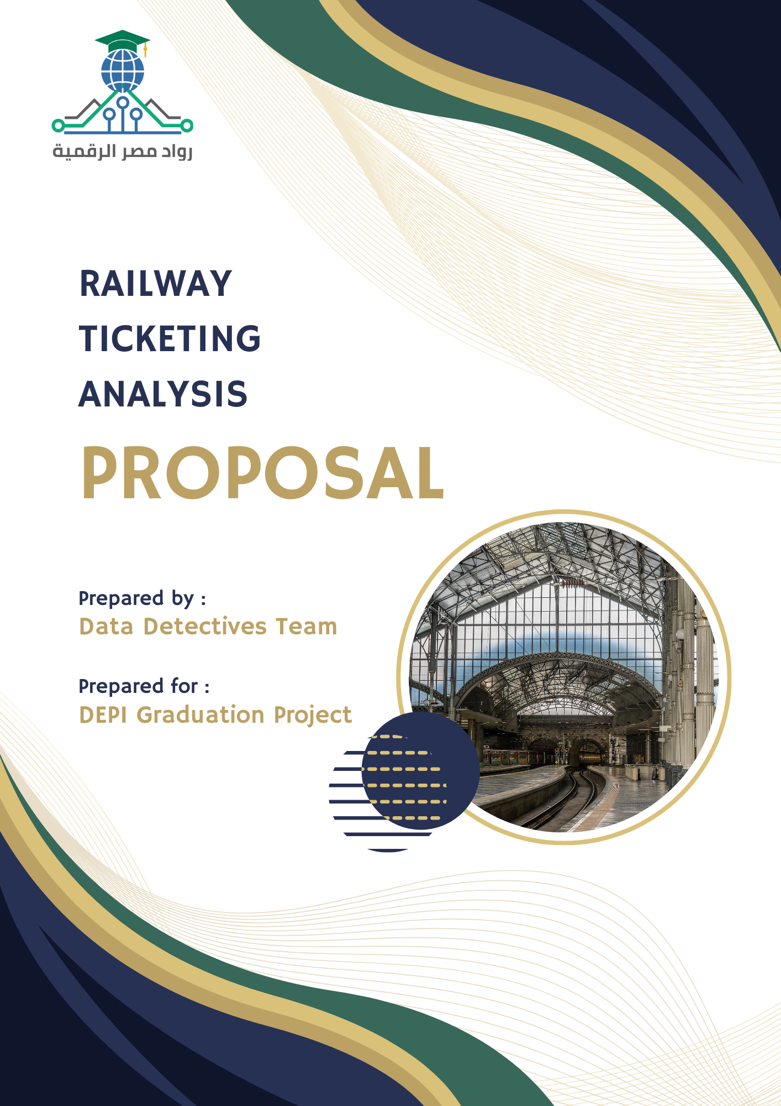

Project Description
Railway ticketing systems generate vast amounts of data, but unlocking their full potential requires a structured analytical approach. This project focuses on transforming raw ticketing data into actionable insights by enhancing data quality through cleaning, transformation, and normalization. Using Power BI and Power Query, we will analyze pricing strategies, customer behavior, journey performance, and refund trends. The ultimate goal is to empower railway operators with data-driven decision-making, improving efficiency, revenue management, and passenger satisfaction.

Group Members & Roles
Member Name | Roles & Responsibilities
Mohamed Waleed Mohamed Abdel Fattah  (Team Leader) | Normalizing data and preparing it for analysis.  Examining booking window impact and station performance analysis.
Abdrabo Gamal Motawea | Researching ticketing system operations and customer segmentation.  Analyzing ticket pricing and customer segmentation.
Nouran Ahmed Mohamed Tawfik | Understanding railway business and defining analytical scope.  Evaluating purchase channels and payment methods.
Abdelrahman Alaa El-Din Ragab | Cleaning and transforming datasets to ensure accuracy and consistency. Investigating journey delays and cancellations.

Objectives
- Identify factors influencing final ticket pricing.
- Analyze customer segments based on railcard status, ticket class, ticket type, and purchase channel.
- Assess the impact of purchase channels (online vs. station counter) on customer behavior and transaction efficiency.
- Determine the most popular payment methods and their correlation with pricing and refund requests.
- Evaluate the influence of National Railcard ownership on purchase behavior and refund rates.
- Investigate the primary reasons for journey delays or cancellations.
- Identify key factors associated with refund requests to optimize the refund process.
- Examine how the booking window affects pricing and journey disruptions.
- Analyze departure and arrival station combinations to determine their impact on journey performance.

Tools & Technologies
- Power BI – The core platform for interactive visualizations and performance analysis.
- Power Query – Facilitates data extraction, transformation, and preparation for analysis.
- DAX (Data Analysis Expressions) – Supports advanced calculations and metric customization.
- Excel – Aids in preliminary data exploration and structuring before integration.

Analysis Approach & Timeline
- Data Cleaning & Preprocessing
- Start Date: Sunday, 16 February 2025
- Due Date: Wednesday, 26 February 2025
Tasks:
- Clean and preprocess the dataset using Power BI.
- Ensure data consistency, handle missing values, and remove outliers.
Deliverables:
- Cleaned dataset ready for analysis.
- Data preprocessing documentation/notebook.

- Analysis Questions & Forecasting
- Start Date: Thursday, 27 February 2025
- Due Date: Saturday, 8 March 2025
Tasks:
- Identify key business questions decision-makers need answers for.
- Predict the number of rides for the next month and forecast daily revenue.
- Analyze demand for different ticket classes.
Deliverables:
- List of analysis questions for further exploration.
- Power BI forecasting model results.

- Dashboard Development
- Start Date: Sunday, 9 March 2025
- Due Date: Tuesday, 18 March 2025
Tasks:
- Design an interactive Power BI dashboard to visualize key insights.
- Ensure real-time data updates where applicable.
- Optimize the dashboard for usability and clarity.
Deliverables:
- Power BI Dashboard showcasing key insights.

- Final Presentation & Report
- Start Date: Wednesday, 19 March 2025
- Due Date: Friday, 28 March 2025
Tasks:
- Compile findings into a detailed report.
- Prepare a presentation summarizing insights, analysis, and recommendations.
- Ensure the report is actionable for decision-makers.
Deliverables:
- Final report covering all phases.
- PowerPoint presentation for project delivery.

Project KPIs
1. Ticket Pricing Drivers and Customer Segmentation
- Average ticket price – To analyze price variations across customer segments.
- Total price (Total Revenue) – To understand revenue distribution.
- Count of each ticket class – To compare Standard vs. First-class pricing impact.
- Count of each ticket type – To analyze pricing differences (Advance, Off-Peak, Anytime).
- The number of people using railcards and count of each type – To assess discount utilization.
- Average ticket price per ticket class and type – Helps in identifying pricing trends across different segments.
2. Impact of Purchase Channel on Transaction Behavior
- Count of online tickets – To analyze digital adoption.
- Count of station tickets – To compare with online ticketing.
- Count of each payment method – To assess purchasing trends and transaction behavior.
- Average ticket price by purchase channel – To check if online or station purchases impact pricing.
3. Payment Method Efficiency and Revenue Implications
- Count of each payment method – To understand customer preferences.
- Total price (Total Revenue) by payment method – To identify high-revenue payment options.
4. Effective Railcard and Customer Loyalty
- The number of people using railcards and count of each type – To analyze discount impact.
- Total revenue from railcard users vs. non-users – To measure financial impact.
- Count of refund requests (Yes, No) by railcard type – To assess if railcard users are more likely to request refunds.

5. Journey Performance Analysis
- Count of on-time and delayed journeys – To measure performance reliability.
- Average time delay – To quantify journey delays.
- Count of each reason for delay – To identify operational issues.
- Number of canceled journeys – To track major disruptions.
- Delay percentage per route – Helps in identifying the worst-performing routes.
6. Refund Request Patterns and Their Correlates
- Count of each refund request (Yes, No) – To measure refund frequency.
- Count of refund requests by delay reason – To analyze refund trends.
- Refund rate by ticket type – To check if some ticket types have higher refund rates.
7. Time-of-Purchase and Booking Window Analysis
- Average time between ticket purchase and journey date – To see how booking lead time impacts pricing and delays.
- Count of last-minute purchases (e.g., within 24 hours of travel) – To assess last-minute booking trends.
8. Route-Level Performance and Customer Satisfaction
- Count of departure station and arrival station – To analyze demand per route.
- Performance ranking of routes based on delays and cancellations – To identify the best and worst-performing routes.
- Refund request rate per route – To see which routes cause the most dissatisfaction.

